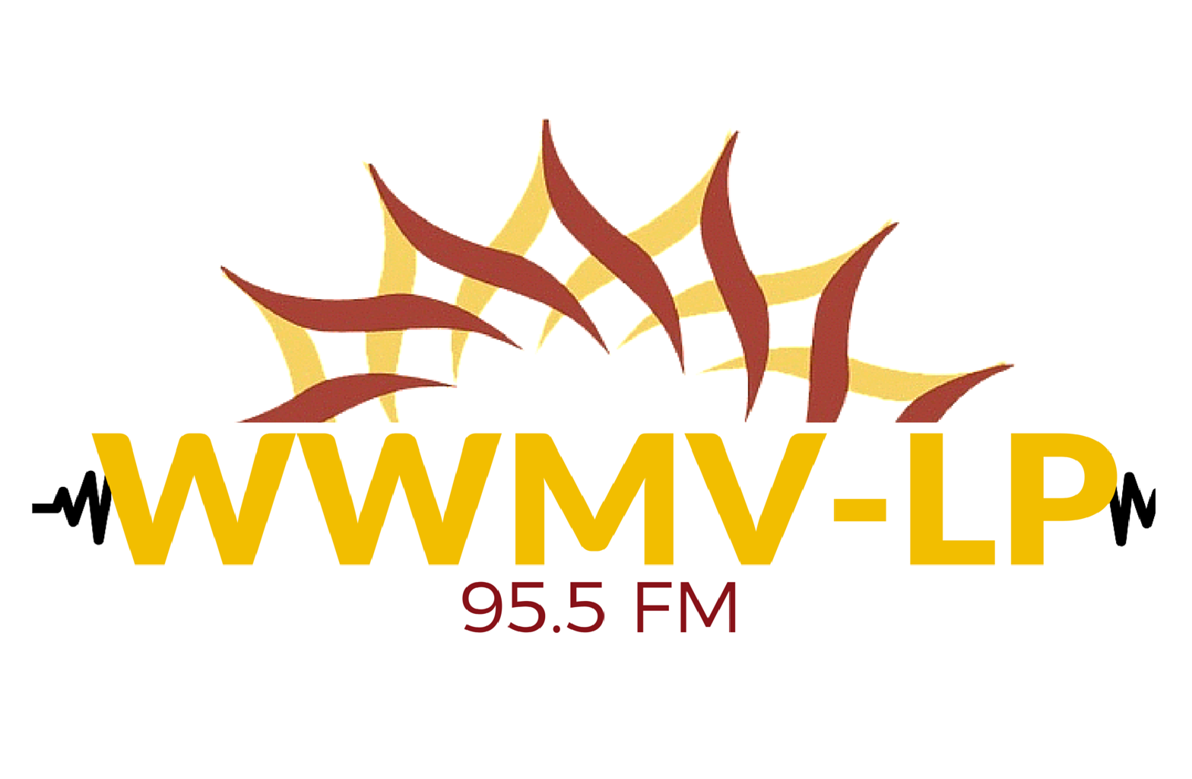
Radio Announcer Application

Mission Statement: WWMV-LP 95.5 builds community by bringing together the full richness of our community to share their gifts, talents, perspectives, and cultures. In partnership with local schools, colleges, community groups, and neighbors, we create opportunities for people of all ages and from all walks of life to develop their own voice and learn new skills.

In order to build community by sharing diverse voices and talents, we are seeking volunteers who would like to host their own radio show of their choice. Shows can be music, talk or both and can be pre-recorded within our studio at LCEC or in your home. Are you the next WWMV-LP announcer? All ages and backgrounds are welcome.

Name:____________________________ Nickname: __________________________

Email:____________________________ Phone:______________________________

Address:____________________________________ Age:_____________________

How did you hear about WWMV-LP?: ______________________________________

Availability (When you available to work on your show)

 | Sunday | Monday | Tuesday | Wednesday | Thursday | Friday | Saturday
1st
2nd
3rd

Show Title: _____________________________________________

- Please describe the show you would like to produce with as much detail as you can provide. What is the content? Talk or music or both? What kinds of guests might you invite to be on your show?

- How does your show align with the mission (see first page) of WWMV-LP? What makes your radio show different?

- How long do you want your show to be? (please circle one)
  - 30 minutes
  - 60 minutes
  - Other _________

- How often do you want to go on air?
  - Weekly
  - Bi-weekly
  - Monthly
  - Other
- What time of day would you want your show to air? Please list preferences
  - _________________

  - _________________

  - _________________

- Please explain your previous radio experience? If you do not have radio experience, what other applicable skills and experiences do you have? (Writing, performing, public speaking, music production, interviewing, etc)

- What resources do you have to execute your show?

- What are some challenges and concerns that you have about the show?

Announcers to Airwaves: The Step by Step Process
WWMV-LP Radio Station Programming is developed by a group of talented local community members. Our dedicated volunteers help determine our line up of shows. To become part of the line up:
- Interested volunteers meet with the Radio Station Manager for discussion, announcer application, and volunteer paperwork
- Volunteer meets with a programming team member for program development and application completion
- Volunteer attends a radio orientation and submits completed application
- Team chooses new shows based on the radio station’s mission, vision, capacity and diversity.
- Team trains and assists selected announcers

All announcers must attend a radio orientation and fill out application

All announcers interested in doing a live show must go through Live Show Training and do 2-3 pre-recorded shows

